Video 1 – Introduction
Videos 2 + 3 – Working with String Variables
As before, create a folder for Week03 inside Code. Create a folder FilmDetails inside Week03.
Open the folder inside VISUAL STUDIO CODE and create a new Terminal.
Create, build and run this application as before using: dotnet new console and dotnet build and dotnet run and similar folders and files will be created as well as the default message.
We want to store information about films so we will create different variables and then display the values assigned to them as follows:
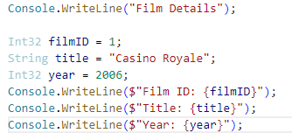
Build and run the application.
Additional Notes
The project template for .NET 6.0 and above generates the following code:
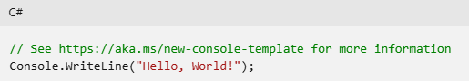
If you click on the link, it will display template for older versions similar to:
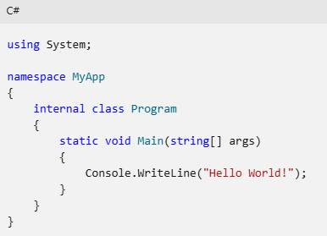
This lets us see the System namespace and the internal class which are part of the .NET core SDK framework. It has a library of code which allows us to use built-in types such as String, Int32 etc. and also define our own classes and types.
Close the folder for FilmDetails in Visual Studio Code, delete the contents of the folder from Windows Explorer, and open the empty folder back in VSC.
This time you will create a new console project using the old program style by using the following code:
Build and run as normal. This will create the following code in the program file:
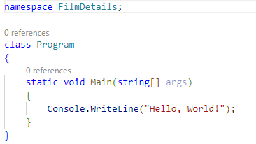
Add the code from before to create 3 variables, assign values and display them as follows:
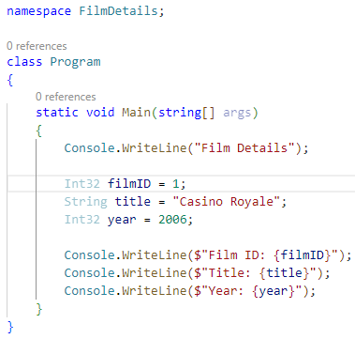
Build and run the application. It should display the details for the film, Casino Royale.

Video 4 – Defining a Class with Properties
This code stores different pieces of information in separate variables. We can store multiple pieces of information to one variable by using a class and we can define our own class with multiple types as follows:
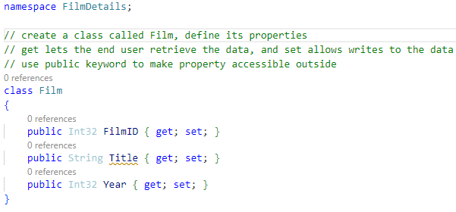
This code should be above the class Program. Notice the Capital at the start for property names, whereas variable start with lowercase.
There may be a warning for Title to contain a non-null value. This will be removed if the nullable statement in the project file, FilmDetails.csproj, is commented out.

Video 5 – Working with a User Defined Class
We now want to work with this user defined class. We can save the values of the variables to a single class. Comment out the code that creates the variables, assigns values and displays them. Add the code in the class Program as follows:
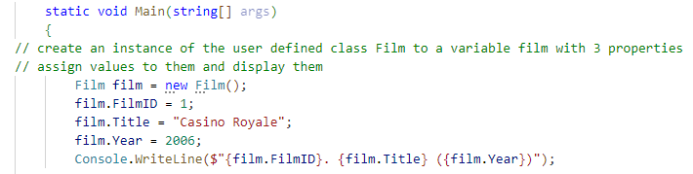
This uses the class Film, initialises it to create a new instance of it to a variable called film, assigns values to the properties of it and displays the values.
Build and run the application. It should display the details for the film, Casino Royale, as before.
Comment out the code and change it to a literal declaration as follows:
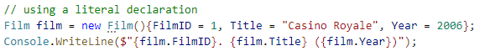
Build and run the application again and you should get the same results.

Video 6 – Working with a User Defined External Class
The class has been created inside Program.cs but it can saved as an external file. Create a new file and call it FilmEntities.cs. Move the code into this file and edit as follows:
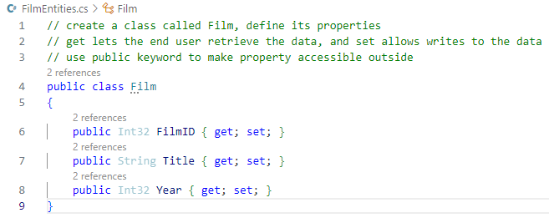
Make the class public as well as the properties. This code is simpler than the video because we’re using a later version of .NET core SDK.

Video 7 – Working with Lists
The previous example works with a single film. If we want to work with multiple films then we can use a list. This lets us save information about multiple films to a single variable using a list.
Add the following code:
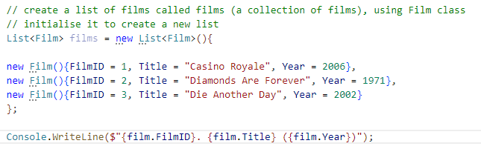
This creates a list and populates it with details about 3 films. But if we build it and run it, it only displays the first film.
If we want to display the contents of a list then we can use a foreach loop, as in previous examples in week 2.
Modify the code as follows:
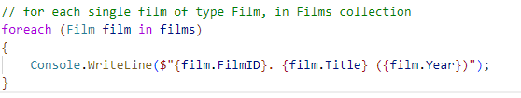
The Console statement is now a block code in a foreach loop so when you run the program it should display the details of all 3 films from the list.

Video 8 – Working with SQL
This video creates a new sql database. Create a new file called Films.sql which defines a table called Films, with 3 attributes and populate it with 25 records. The file, Films.sql can be downloaded.
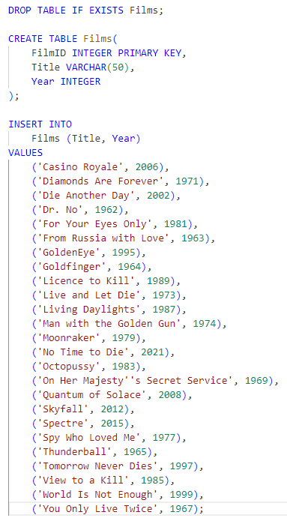
The code should be familiar if you have used databases, or sql before. If not, there are many resources available.

Video 9 to 12 – Executing SQL / Adding Multiple Records
Run the following command from the power shell prompt:
This command runs the sqlite engine installed in week 1 and creates a database file named Films.db using the script code in the file Films.sql using the initialisation switch.
When you execute the command, it takes you to the sqlite prompt and a database file should be displayed in the explorer panel. Type .exit to return to the power shell prompt.
Notice another file, Films.db has been created and is displayed in the Explorer panel within VSC.
Use Windows Explorer to go to wherever you installed SQLiteStudio and double click on the executable file, SQLiteStudio.exe to run it.
Select Database, Add a Database, choose the folder for the File option and navigate to Films.db in the FilmDetails folder within the Week3 folder and choose OK. When you double click on Films, you can the table Films. Double click on this and there are different tabs.
Select Structure to view the design of the table ie the attributes, data type, PK etc.
Select Data to view the records of all the data populated from the script file.

Video 13 – Referencing Entity Framework Core
Program.cs shows how the details of 3 James Bond films are hard coded into it. It would be useful to access the films details from the Films database.
In order to access a database, we need to make use of other tools. Open the project file, FilmDetails.csproj and the default package is what version of .NET we are using.
We need to add another package as follows:
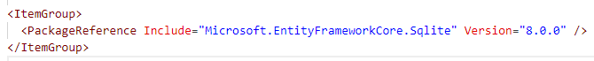
This adds a reference to another package, and we specify the name of the package to include and the version which should correspond to the version of .NET being used.
This package provides a range of tools that will allow our application to access an sqlite database.
Build the program to check there are no errors.

Video 14 – Creating an Entity Class
If you are going to be using a database, it is common practice to create an entities file that matches the tables in your database. So, a class file should match a record in the table so use the same names for the properties of the class as the attributes of the table to maintain consistency. Essentially, a class describes a record in the table.
You can go back to SQLite Studio to view the structure of the table Films.db in the Films database.
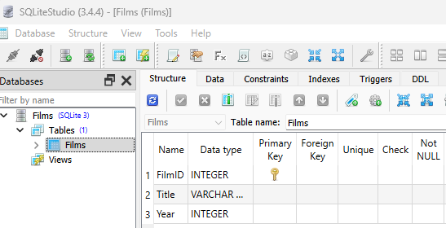
In video 6 we created a file called FilmEntities.cs which defined a class called Film with 3 properties. Notice the names and types match the database structure. So, each entity file could be used to hold one of the database records in Film.db.
C# is strongly typed so a mismatch will generate an error. This is a common problem so double check the names match to avoid unnecessary problems.

Video 15 – Creating a Context Class
A context file allows us to connect to a database and retrieve data from the tables that we want to work with in our project.
Create a new file called FilmContext.cs and add the following code:

Video 16 – Inheriting the DbContext Class
Modify the code as follows:
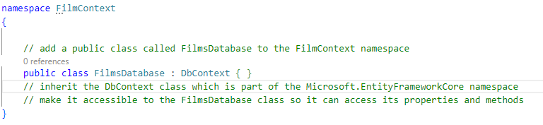
Access to the DbContext class should make connecting to a database more straightforward.

Video 17 – Defining a DbSet Property
Modify the code as follows:
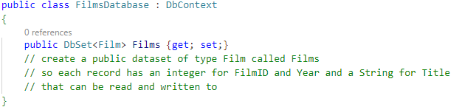
When we connect to the database we can retrieve a dataset named Films and each item in the dataset will be a film which has an ID, title and a year.
If we were using more than one table, eg Actors we would need to create a dataset for this within the class FilmsDatabase such as:
We would also need to create a public class for Actor in the file, FilmEntities.cs which matches the attributes in the table in the same way as we did for the Film class and the Films table.

Video 18 – Connecting to the Database
We need to specify how to connect to the database and which one as we could have multiple databases in our application.
Add the code as follows:
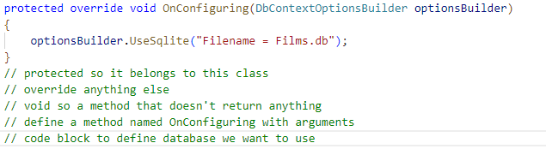
The code may look complex, but it is standard bulk code to allow an application to connect to a database.
You should continue to build and run the application even when you don’t expect any changes as it lets you know your code is correct and error free.

Note:
When you use an application which connects to a database, it is common practice to be able to carry out CRUD operations (create, read, update and delete) on the records. The next few examples show how each of these can be done.

Video 19 – Displaying Records
The video adds namespaces to the program file but some of these are not required in the current version of .NET
When you run the application, it will display details of 3 films that re hard coded into a list in Program.cs using the code:
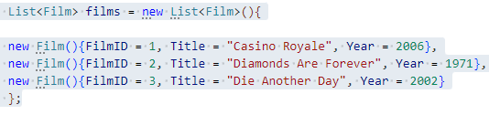
Comment out these lines. We now want to connect to the database so that we can display details for all 25 records from the Films table in the Films database.
You need to add the code below to the program file to use the FilmContext namespace to access the database:
Add the following code:
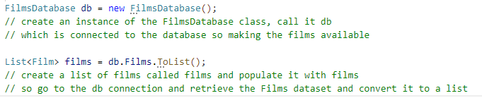
Build and run the application.
The foreach loop which was used before should go through each record in the dataset and display 3 pieces of information for all 25 films.

Video 20 – Inserting a New Record
We want to be able to add a new record to the database. Firstly, we want to prompt the user to enter a new film title and a year. The ID is generated automatically.
Then we want to create a Film object which contains the information that we want to add to the database.
Add the following code:
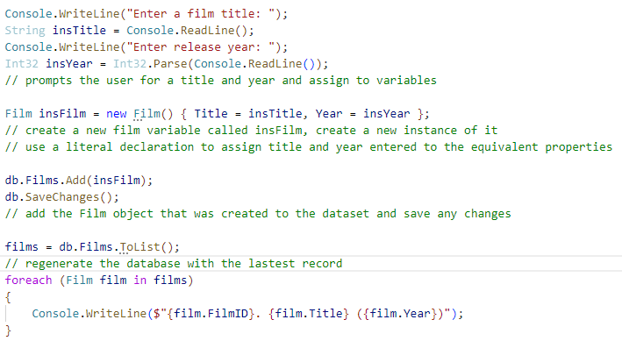
Build and run the application. It should display the 25 records and then prompt for a title and year and then display an updated list with the new entry.

Video 21 – Regenerating the Database
When you start making changes to the database, the original has changed. You can check this by opening the database in SQLite Studio and viewing the records. You may need to refresh the data.
But you can go back to the original at any time by issuing the same command again from the power shell prompt:

Video 22 – Selecting a Record
It might be useful to select a specific record. So before we add new code, comment out the block of code for inserting a new record and displaying an updated list. Build and run the application and you should get a list of the current records in the database. If you regenerated the database, then you should get a list of the original 25 records.
The best way to select an individual record would be to use the FilmID as this should be a unique attribute. So once we have a film ID entered by the client, we use this information to retrieve a particular record.
Add the following code after commented out line db.SaveChanges()
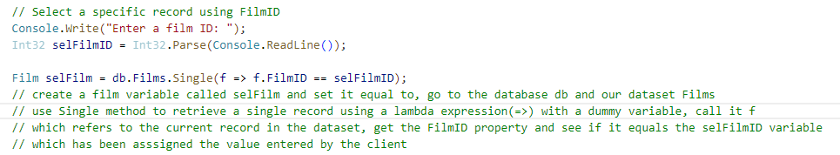
Now the value entered by the client is saved to a variable selFilm.
At this stage, build and run the application to check for errors. It should prompt the client to enter a film ID. We need to add the following code to display information about the selected film ID:
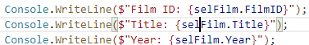
Build and run the application.
Lambda expressions will be looked at in more detail next week.

Video 23 – Deleting a Record
It should be more straightforward to delete a record now that we can select an individual record.
Add the following code:
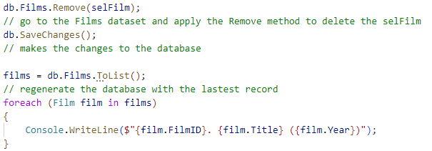
This commented out the lines to regenerate the database.
Build and run the application. It should now display the list, prompt the client to enter a film ID, and finally display an updated list which confirms the record has been deleted from the dataset.
You should also check the record has been deleted from the database by viewing the data in SQLite Studio. You will need to refresh the database.
Video 24 – Updating a Record
The final CRUD operation is to update an existing record. So, comment out the code to remove a record.
The client can enter a film ID to select a particular record, and we now want to allow the client to change the values for this record. The ID cannot be changed as it was setup as an auto-increment, but the client can update the title and/or year attribute.
Add the following code:
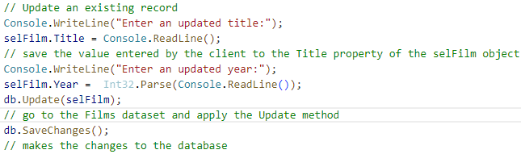
This prompts the client to enter an updated title and year and then applies these by updating the dataset and saving the changes to the database.
Build and run the application and view the database in SQLite Studio to confirm the changes.
Video 24 – Running a Database Application
Comment the code to select and update a record.
Comment out the code to prompt the use press any key to exit.
The final application creates an instance of the FilmsDatabase class defined in FilmContext.cs, gets a dataset of films and converts it to a list of named films and uses a foreach loop to display all of these films.
Build and run the final application which should display a list of the films.
Try and run the application from Windows Explorer and it will throw up a critical error, No such table – Films.
If you check the size of the file Films.db, it will be 0 KB so it is empty. Delete this file. Move up to the level FilmDetails and there will be another file, Films.db which should not be empty. Copy this file back into the bin/Debug/8.0 subfolder.
Run the application again from Windows Explorer and hopefully the records will be displayed.
It important to remember that whenever you build a console application using a database, you need to copy the database file into the binaries folder where the executable file is located.
Also you can go back to video 21 to recreate the original database as follows:

